|  |  |
| --- | --- |
| **NATIONAL INSTITUTE OF TECHNOLOGY, RAIPUR**  **Branch: Computer science & Engineering**  **B.TECH (......) End Semester Examination 2021**  **Subject: PPL**  **Domain Area: Data Structures in Prolog**   |  | | --- | | **Name: Kunal Sachdeva**  **Roll No: 19115045**  **Semester: Fourth**  **Title of Term Paper/Term Project/Conference: How sequence diagram is used in prolong based approach**  **Date of Submission: 31/03/2021**  **Signature:**  **Submitted to: Ms. Rakhi Seth (teachers Name)**  **Teachers Signature:.................................................**  **Remarks:...............................................................................................................**  **................................................................................................................................**  **................................................................................................................................ ................................................................................................................................**  **........................**  **Graded By: A+, A, B+, B, C+, C**  **Total Marks: ........./30** | |

**Abstract**

UML is an industrial standard for designing and developing object-oriented software. It provides a number of notations for modelling different system views, but it still does not have any means of meticulously checking consistency among the models. These models can contain overlapping information which may lead to inconsistencies. If these inconsistencies are not detected and resolved properly at an early stage, they may result in many errors in implementation phase. In this paper, we propose a novel approach for consistency checking of sequence diagrams based on Prolog language. In the proposed approach, consistency checking rules as well as UML models are represented in Prolog, then Prolog’s reasoning engine is used to automatically find inconsistencies**.**

**Introduction**

In system development lifecycle, design phase plays an important role as a basis for implementation. During design phase, system is modelled in such a way as to bridge the gap between analysis and implementation phase. It is essential to detect model inconsistencies at an early stage, so that the inconsistencies will not propagate to code or customer deliverables, such as, documentation [9]. If design phase is modelled properly then process of up-gradation and maintenance of system becomes easy.

An important quality of design is that it should be understandable. To increase the design understandability different design methods and notations have been developed. But for the past few years Unified Modelling Language (UML) [1] is accepted as an industrial standard for object-oriented system modelling. The software design is usually represented as a collection of UML diagrams. UML is a very flexible modelling language as it provides number of notations for modelling different system perspectives, e.g., static view (class diagram) and dynamic view (sequence diagram). It also has a wide range of tools covering up all the features of system modelling for complete and comprehensive representation.

Cost of software development also decreases by performing consistency checking between different UML artifacts. Especially after the emergence of MDA [16], object-oriented code can be generated from UML models. So, for reliable and correct code generation UML artifacts need to be consistent for which model consistency checking is desirable. Similarly, modifications in model are relatively simple as compared to the changes in source code. After modifications in model, once again consistency checking is required to validate models.

In this paper we present an approach that transforms UML models into Prolog [3] to perform consistency checking. Use of Prolog is motivated by the fact that it is a declarative programming language that provides beneficial assistance representing arbitrary concepts based on inference rules. It is also quite expressive for the types of consistency rules we deal with.

**Inconsistency and Consistency Checking Types:**

This section describes the consistency checking types as given by Mens. [12].

**Consistency Checking Types**

**Vertical Consistency.** Consistency checking is performed between diagrams of different versions or abstraction-levels. Syntactic and semantic consistencies are also included in it.

**Horizontal Consistency.** Horizontal Consistency checking is performed between different diagrams of same version.

**Evolution Consistency.** Evolution Consistency checking is performed between different versions of a same UML-artifact.

Inconsistencies we consider include both structural, which appears in class diagram, and behavioural that appears in sequence diagram. In current paper we deal with the type of consistency known as horizontal consistency. Inconsistencies that can occur are described in next section.

**Inconsistency Types**

**Dangling Feature Reference.** This type of inconsistency occurs when message in sequence diagram references to a method that does not exists in class diagram.

**Multiplicity Incompatibility.** This type of inconsistency takes place when the link in sequence diagram does not follow the multiplicity constraints defined by corresponding association in class diagram.

**Dangling Association Reference.** This type of inconsistency occurs when a link is defined between objects in sequence diagram and it has no association between classes of corresponding objects.

**Classless Connectable Element.** This type of inconsistency occurs when object’s lifeline in sequence diagram refers to the class that does not exist in class diagram.

**Related Study**

In this section, the existing UML model consistency checking techniques are discussed. For consistency checking many techniques transform the UML model in some intermediate form, by applying the rules presented in different techniques.

Straeten [2, 11] present a technique for consistency detection and resolution using DL (Description logic) [14]. The authors present an inconsistency classification. A UML profile is also developed to support consistency of UML artifacts and then LOOM tool [15] is used for translation of developed profile into DL. Consistency checking is performed for messages, associations and classes but not for constraints and multiplicity.

Krishnan [4] presents an approach for consistency checking based on translation of UML diagrams in state predicates. Only UML behaviour diagrams are covered. After translation, PVS (prototype verification system) a theorem prover as well as a model checker is used to perform consistency checking.

Muskens [5] present an approach for intra and inter phase consistency checking, which makes use of Partition Algebra using verification rules. Consistency checking is performed by deriving the rules from one view and imposing them on the other view. Consistency checking is performed for associations, messages and constraints.

Egyed [6] introduces a consistency checking technique known as View-Integra. In this technique the diagram to be compared is transformed in such a way that it becomes conceptually close to the diagram with which it is going to compare. Consistency checking is performed between same artifacts, one is original and other one is transformed. Technique is partially automated.

Ehrig [7] propose a technique to perform consistency checking between sequence and class diagram based on Attributed Typed Graphs and their transformation. Consistency checking is performed for existence checking (means all classes used in sequence diagram exist in class diagram), visibility checking (visibility of classes, attributes and operations, all should be visible to sequence diagram) and multiplicity checking. Their approach is not supported by any tool support.

Briand [8, 14] propose an approach for change impact analysis based on UML models. This technique is applied before changes are implemented to estimate the effect of change. Some rules are formally defined using OCL to determine the impact of change on different versions of models. A prototype tool is implemented which also executes consistency checking rules defined.

Paige [10] present an approach to formalize and describe the implementation of consistency constraints between two views of BON (Business Object Notation) i.e., class and collaboration diagram. PVS theorem prover is used to automate the proofs. Consistency checks performed includes sequencing consistency checks (order of message calls), class existence and routine (operation) existence.

Storrle [13] proposes a Prolog based model representation and query interface for analysis of models in MDD (Model Driven Development) setting. Models and queries are represented on the basis of representation defined for Prolog clauses. Queries are used for identifying elements, properties and sub-models of models.

**Methodology Used**

The proposed approach is an idea of checking consistency of sequence diagram. For this purpose, UML models as well as consistency rules are represented in Prolog and then reasoning is performed in Prolog. Our technique provides better coverage of the model and can also be extended to check consistency between OCL constraints of both UML artifacts. Flow diagram of proposed approach is given in Figure 1.

Inconsistencies

Prolong representation of rules

Reasoning Engines

Prolong representation of UML Models

Conversion

UML Model

*Fig. 1. Flow diagram of Proposed Approach*

**Representation of UML Model/Sequence Diagram in Prolog**

Sequence Diagrams

SequenceDiagram

+Sequence

+Sequence

Sequence

+Data

is a call to

+Method

+Message

+sender

+receiver

+Message

OccurrenceStart

OccurrenceEnd

Message

Method

Object

is a call to

Synchronous

Data

Asynchronous

*Fig. 2. UML Meta-model for Sequence diagram*

Keyword ‘object’ is actually name of predicate. ‘Objid’, ‘Objname’ and ‘Classid’ are object identifier, object name and class identifier respectively. ‘Multiobj’ has value of T(true) or F(false), which tells whether multiple instances exist or not.

mcall(Msgid ,Opname ,[Parameter-list] ,Sndobjid ,Recobjid).

Keyword ‘mcall’ stands for method-call is predicate name. ‘Msgid’, ‘Opname’ and [Parameter-list] are for message identifier, operation name and parameter-list of operation respectively. ‘Sndobjid’ and ‘Recobjid’ is sending object name and receiving object name.

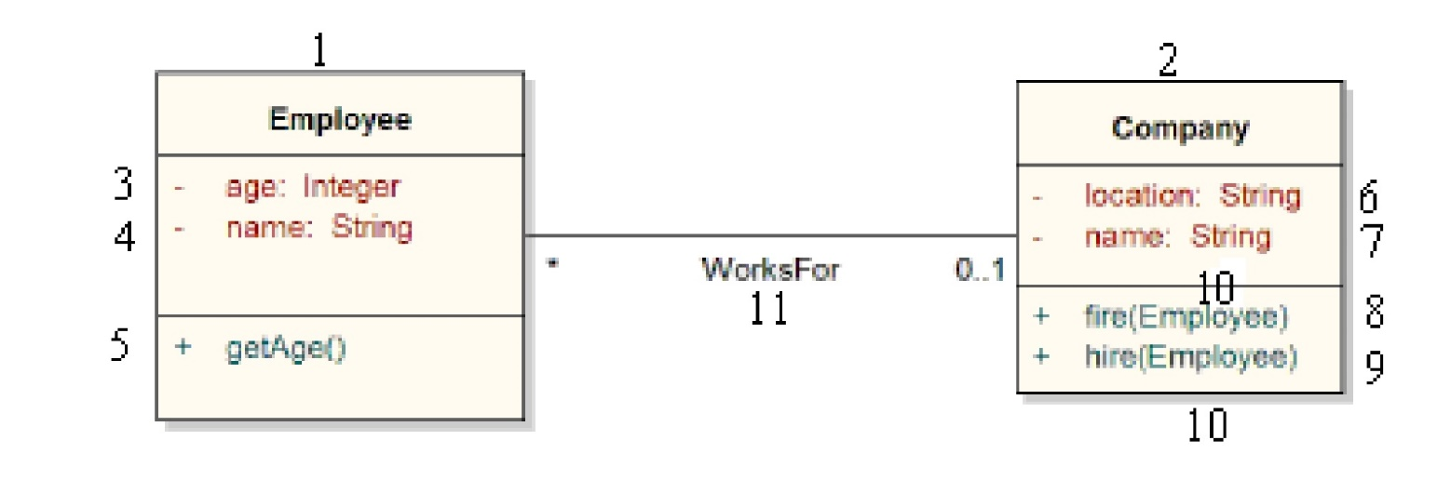Below is an example of class and sequence diagram representation according to our proposed representation of UML model in Prolog. Both diagrams are taken from [15].

*Fig. 4. Example Class Diagram [15]*

*class(1, Employee).*

*attribute(3, age, integer, 1).*

*attribute(4, name, String, 1).*

*operation(5, getAge, [ ], 1).*

*class(2, Company).*

*attribute(6, location, String, 2).*

*attribute(7, name, String, 2).*

*operation(8, fire,[10], 2).*

*operation(9, hire, [10], 2).*

*parameter(10, Employee, Employee).*

*association(11, 1, 2).*

*multiplicity(11, 1, 0, 1).*

*multiplicity(11, 2, 0, n).*

*object(1, ACME, 2, F).*

*object(2, Andrea, 1, T).*

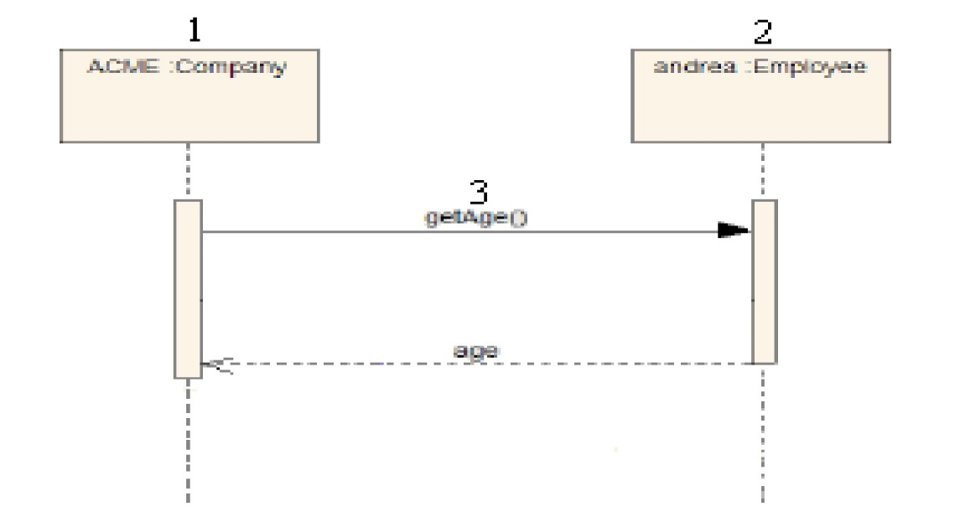*mcall(3, getAge, [ ], 1, 2).*

*Fig. 5. Example Sequence Diagram [15]*

**Consistency Checking Rules**

In this section we have proposed some rules for consistency checking of UML models based on Prolog predicate.

**Classless Connectable Element.** Occurs when object’s lifeline in sequence diagram refers to the class that does not exist in class diagram. Here object’s information is brought from database using object clause and from that information class identifier is extracted and compared with all class predicates in database to check class existence. In case of negative results of comparison an error message is returned defining inconsistency.

*objcl_exist_rule(ClCele):-*

*object(Objid,_,_,_),*

*object(Objid,N,Classid,_),*

*((\+class(Classid,_),*

*ClCele="Error: 301");*

*fail.*

**Dangling Feature Reference.** Occurs when message call in sequence diagram refers to method that does not exist in class diagram. In this rule using method call clause, required information is brought from database and from that information object identifier is extracted to find out the related object. Finally, operation existence in corresponding class is checked on the basis of information taken from object. If operation does not exist an error message is returned.

*op_exist_rule(DfRef):-*

*mcall(Msgid,_,_,_),*

*mcall(Msgid,Opname,_,Recobjid),*

*object(Recobjid,_,Classid,_),*

*((\+operation(_,Opname,_,Classid),*

*DfRef="Error: 302");*

*fail.*

**Dangling Association Reference.** Occurs when there is link between objects in sequence diagram while no association between corresponding classes of class diagram. In this rule first required information about method call and object is gathered from database using ‘mcall’ and ‘object’ clauses and then on the basis of gathered information comparison is made to check existence of association between classes. If association does not exist an error message is returned.

*assoc_exist(DaRef):-*

*mcall(Msgid,_,_,_),*

*mcall(Msgid,_,Sndobjid,Recobjid),*

*object(Sndobjid,_,ClassA,_),*

*object(Recobjid,_,ClassB,_),*

*((\+association(_,ClassA,ClassB),*

*DaRef="Error: 303");*

*fail.*

**Multiplicity Incompatibility.** Occurs when multiplicity constraints of both artifacts are not matching. In this rule required information is collected from database using ‘mcall’, ‘object’ and ‘association’ clauses. From gathered information, receiving object is checked whether it’s a multi-object or not and on the basis of this further comparison is made to check the multiplicity constraints. If constraints are nonmatching then an error message is returned containing details of inconsistency.

*mlp_in_rule(MulIn):-*

*mcall(Msgid,_,_,_),*

*mcall(Msgid,_,Sndobjid,Recobjid),*

*object(Sndobjid,_,ClassAid,_),*

*object(Recobjid,_,ClassBid,BMulti),*

*association(Associd,ClassAid,ClassBid),*

*((BMulti == t,*

*multiplicity(Associd,ClassBid,_,UpvalB),*

*((UpvalB =< 1,*

*MulIn="Error: 304");*

*(UpvalB > 1)));*

*(BMulti == f,*

*multiplicity(Associd,ClassBid,_,UpvalB),*

*((UpvalB < 1,*

*MulIn="Error: 304b");*

*(UpvalB =:= 1)))),*

*fail.*

**Result & Discussion**

Technique proposed in current paper is automatable. For automation of technique certain steps are to be followed. First UML models are converted so that information contained in models can be represented in prolog. This is done by generating XMI of each model, which is by default generated, with each model, in existing CASE tools( e.g., Together). Then from XMI relevant information or information to be matched is extracted and represented in the form of Prolog predicates, which are of first order. After model conversion to prolog predicates, consistency rules from rule database along with converted models are presented to reasoning engine. Reasoning engine performs reasoning on prolog predicates generated from models based on consistency rules and return error code of inconsistencies if any.

**Conclusion**

UML is an industrial standard for designing and developing object-oriented software. To obtain consistent and correct information from UML artifacts, consistency checking of artifacts is required. Also, consistency checking plays very important role in reliable and correct code generation in MDD setting, as correct code is generated only if models are consistent. In this paper we present a prolog based consistency checking technique for sequence diagrams, Proposed technique provides better diagram coverage and also covers more inconsistency types. Further work can be done by including more elements of the artifact. More artifacts can also be added by covering all elements of those artifacts to avoid skipping minor details in models.

**References**

1. Object Management Group. Unified Modelling Language specification version 2.1.2. formal/2007-11-01 (November 2007)

2. Simmonds, J., Van Der Straeten, R., Jonckers, V., Mens, T.: Maintaining consistency between UML models using description logic. In: Proceedings Langages et Modèles à Objets 2004, RSTI série L’Objet, vol. 10(2-3), pp. 231–244. Hermes Science Publications (2004)

3. Clocksin, W.F., Mellish, C.S.: Programming in Prolog, 2nd edn. Springer, Heidelberg (1984)

4. Krishnan, P.: Consistency Checks for UML. In: The Proc. of the Asia Pacific Software engineering Conference (APSEC 2000), pp. 162–169 (December 2000)

5. Muskens, J., Brill, R.J.: Generalizing Consistency Checking between Software Views. In: Proceedings of 5th Working IEEE/IFIP Conference on Software Architecture (WICSA 2005), pp. 169–180 (2005)

6. Egyed, A.: Scalable consistency checking between diagrams -The VIEWINTEGRA Approach. In: Proceedings of the 16th International Conference on Automated Software Engineering, San Diego, USA (November 2001)

7. Ehrig, H., Tsiolakis, A.: Consistency analysis of UML class and sequence diagrams using Attributed Typed Graph Grammars. In: Proceedings of joint APPLIGRAPH/ GETGRATS workshop on Graph Transformation systems, Berlin (March 2000)

8. Briand, L.C., Labiche, Y., O’Sullivan, L., Sowka, M.M.: Automated Impact Analysis of UML Models. Journal of Systems and Software 79(3), 339–352 (2006)

9. Paige, R.F., Ostroff, J.S., Brooke, P.J.: A Test-Based Agile Approach to Checking the Consistency of Class and Collaboration Diagrams, UK Software Testing Workshop, University of York, September 4-5 (2003)

10. Paige, R.F., Ostroff, J.S., Brooke, P.J.: Checking the Consistency of Collaboration and class Diagrams using PVS. In: Proc. Fourth Workshop on Rigorous Object-Oriented Methods. British Computer Society, London (March 2002)

11. Straeten, R.V.D., Mens, T., Simmonds, J.: Maintaining Consistency between UML Models with Description Logic Tools. In: ECOOP Workshop on Object-Oriented Reengineering, Darmstadt, Germany (July 2003)

12. Mens, T., Straeten, R.V.D., Simmonds, J.: A Framework for Managing Consistency of Evolving UML Models. In: Yang, H. (ed.) Software Evolution with UML and XML, ch.1. Idea Group Inc. (March 2005)

13. Störrle, H.: A PROLOG-based Approach to Representing and Querying UML Models. In: Cox, P., Fish, A., Howse, J. (eds.) Intl. Ws. Visual Languages and Logic (VLL 2007). CEUR-WS, vol. 274, pp. 71–84. CEUR (2007)

14. Briand, L.C., Labiche, Y., O’Sullivan, L.: Impact Analysis and Change Management of UML Models. In: Proceedings of the 19th International Conference Software Maintenance (ICSM 2003), pp. 256–265. IEEE Computer Society Press, Amsterdam (2003)

15. Baruzzo, A.: A Unified Framework for Automated UML Model Analysis. PhD thesis, Department of Mathematics and Computer Science, University of Udine, Italy (July 2006)

16. Object Management Group (OMG), MDA Guide, Version 1.0.1 (2003),